New Student registration flow

**Problem statement:** Registering new student on DTML platform is challenging for the schools. Many students don’t have email account and captcha is very hard to solve for the little kids. DTML reviewed different alternatives to keep our platform secure from one side and usable from another. Below is the work which was approved by the schools.

*Current student registration flow:*

There are two options for user registration now. One is to create an account by using email and another is by using MSA:

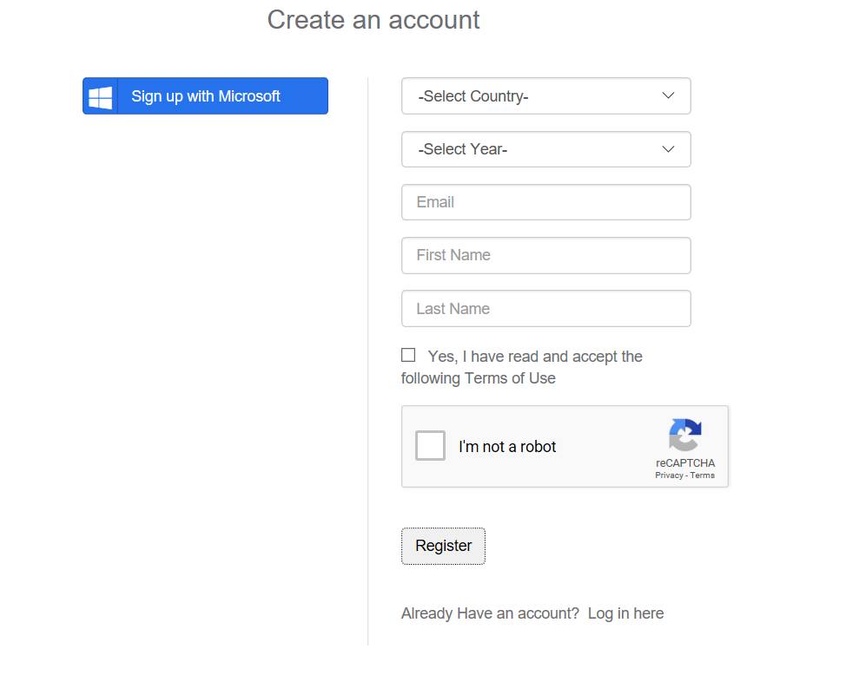

Both flows should remain UNCHANGED but the new registration option should be added

New Registration flow

1. Add new button: Signup with School ID. CSS for icon: fa fa-mortar-board

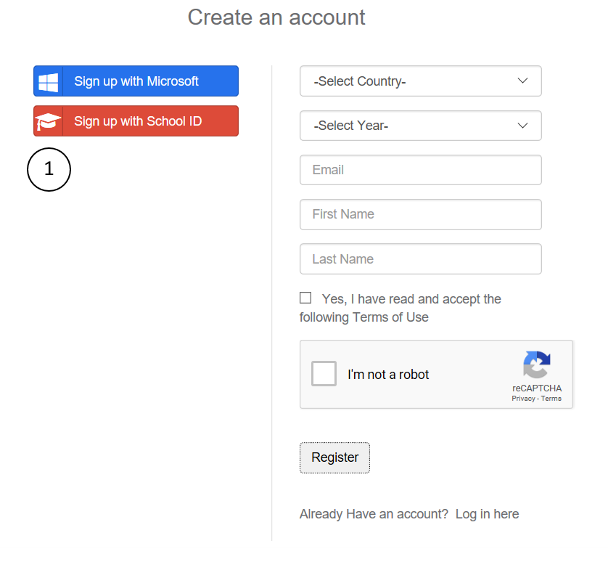

1. Upon clicking on that button, new form should be show on the right:

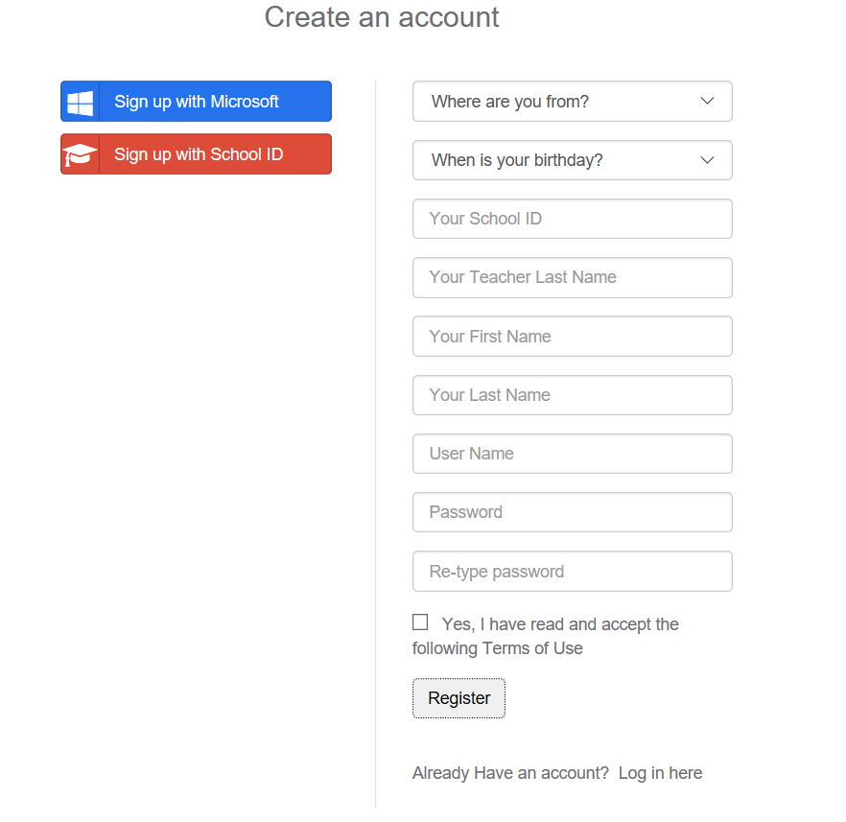

**Note:**

1. Captcha is removed for that flow.
2. Password should be at least 8 characters and contains letters and numbers.

Server-side changes for new flow:

1. Introduce new action on RegistrationController

[HttpPost]

[AllowAnonymous]

public async Task<ActionResult> StudentRegisterWithSchoolID(StudentSchoolIDR model, string _testRequest)

{

….

}

1. Create new helper function CreateApplicationUserWithUserName() (see CreateApplicationUser existing function as a reference)

Registration flow sequence diagram is below.

Tests: New unit and functional tests needs to be added.

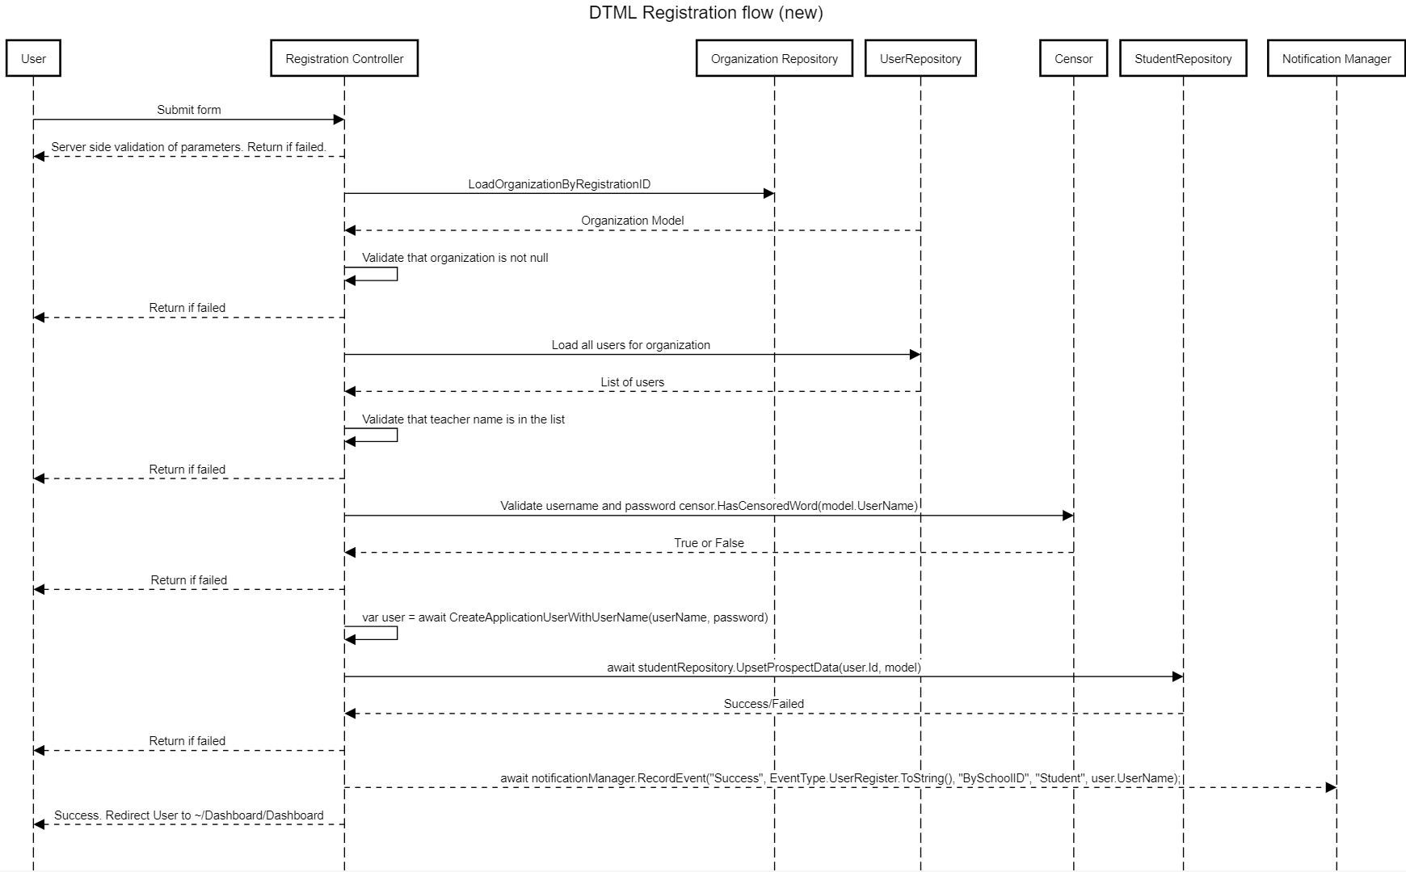

DTML Registration flow (new) <https://sequencediagram.org/>

User->Registration Controller:Submit form

User<--Registration Controller:Server side validation of parameters. Return if failed.

Registration Controller->Organization Repository:LoadOrganizationByRegistrationID

Registration Controller<--UserRepository:Organization Model

Registration Controller->Registration Controller: Validate that organization is not null

Registration Controller-->User:Return if failed

Registration Controller->UserRepository:Load all users for organization

Registration Controller<--UserRepository:List of users

Registration Controller->Registration Controller: Validate that teacher name is in the list

Registration Controller-->User:Return if failed

Registration Controller->Censor:Validate username and password censor.HasCensoredWord(model.UserName)

Registration Controller<--Censor:True or False

Registration Controller-->User:Return if failed

Registration Controller->Registration Controller: var user = await CreateApplicationUserWithUserName(userName, password)

Registration Controller->StudentRepository:await studentRepository.UpsetProspectData(user.Id, model)

Registration Controller<--StudentRepository:Success/Failed

Registration Controller-->User:Return if failed

Registration Controller-->Notification Manager: await notificationManager.RecordEvent("Success", EventType.UserRegister.ToString(), "BySchoolID", "Student", user.UserName);

Registration Controller-->User:Success. Redirect User to ~/Dashboard/Dashboard

With this new functionality, students might not have an email address in our system and might not be able to recover password. To solve that we need to modify organization flow to allow teachers to reset password.

**Organization functionality should change as following:**

<https://dtml.org/Organizations/OrganizationDashboard/Students>

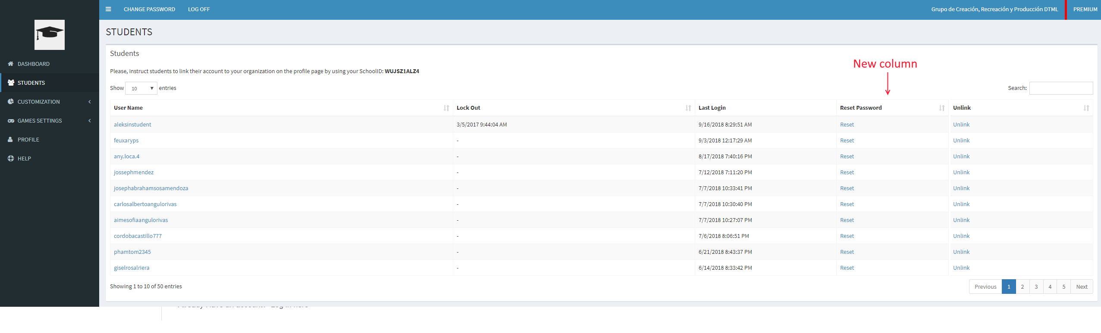

Clicking reset should show modal window:

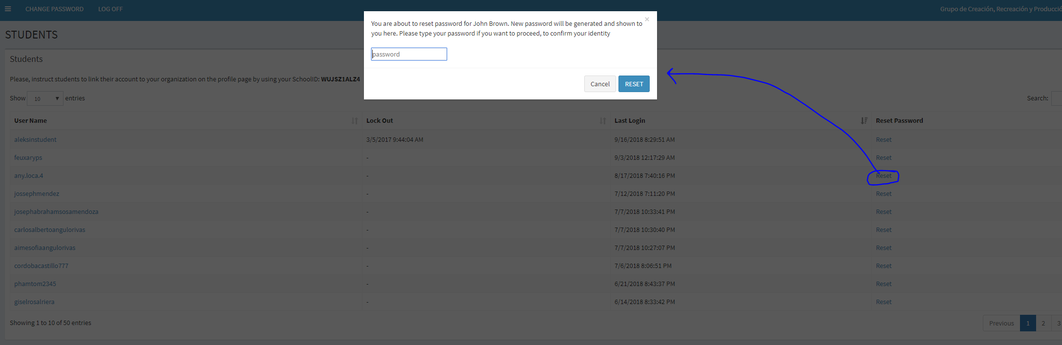

Teacher should enter her or his password to confirm student password reset.

